
ABN 44 023 477 348
Waverley Hockey Club (Inc)
P.O. Box 2069
Mount Waverley 3149

Ground and Club Room
Cnr High Street Road and Winbirra Parade
Ashwood 3147
Ph: (03) 9807 7805

www.waverleyhc.org.au

Waverley Summer Intraclub Competition Registration

To register for the 2015 Intraclub, please register online via Hockey Victoria registration system. To access the registration page, please visit the Hockey Victoria website (http://www.hockeyvictoria.org.au/) and click on the “HV MEMBERSHIP ICON”. This will bring you to the Registration Home Page.


There are How To Guides and FAQs to assist with the registration process which are available on the Hockey Victoria Website and on the registration page:
http://www.hockeyvictoria.org.au/ABOUT-US/Player-Registration-FAQs

Please note if you have previously played for a different club you will need to complete a dual club registration (or request a transfer), with instructions outlined in the above How To Guides FAQ sections on the Hockey Victoria website.

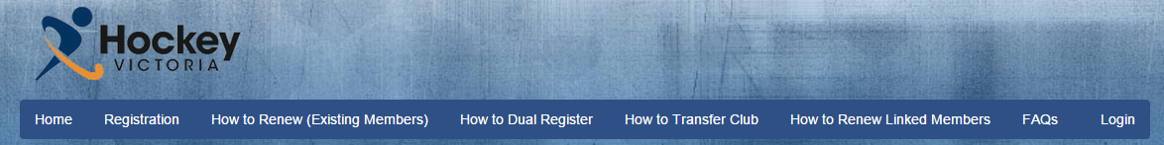

Once you begin the Registration, you will be asked to select a Category, Association and Club. Please ensure that you select “Hockey Victoria (Comps)”, “Hockey Victoria – Metro” and “Waverley Hockey Club” for the Category, Association and Club respectively.

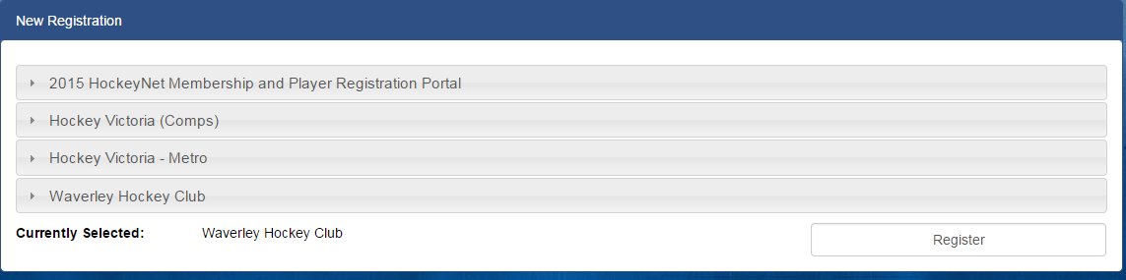

You will then be brought to the subscriptions page.

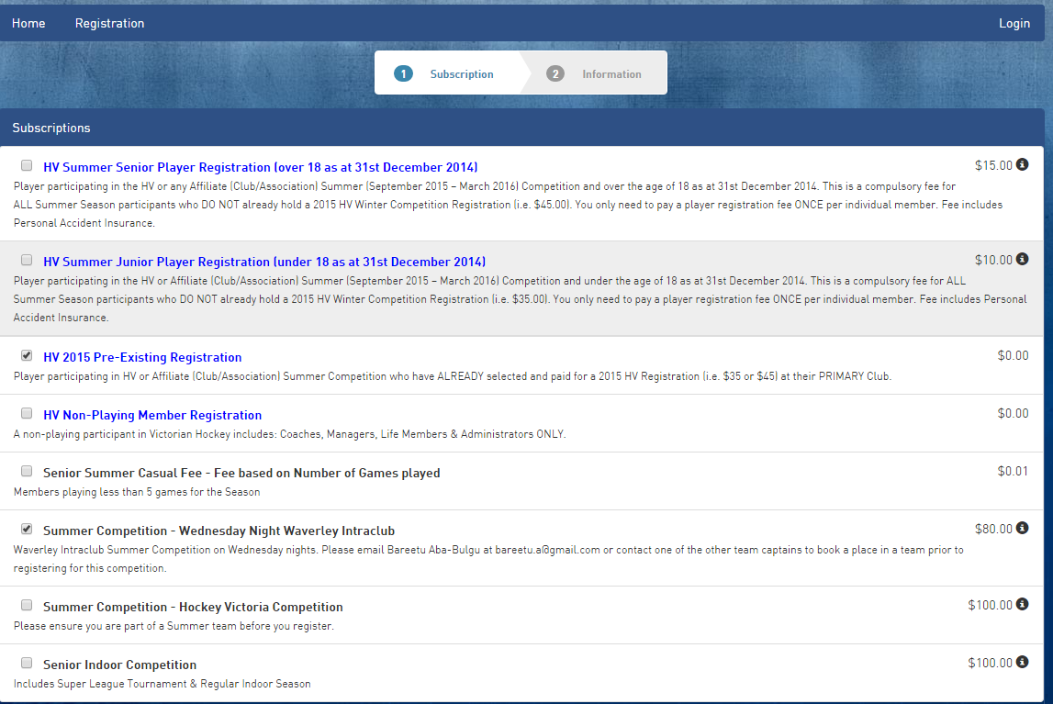

The subscriptions in blue text are the Hockey Victoria fees and the subscriptions in black text are the Club fees. You will need to select two boxes.

Please select one Hockey Victoria subscription (blue text) and a Club subscription (black text).

Blue Text: If you already played for the Winter Season please select the “HV 2015 Pre-Existing Registration Option” (blue text). If you did not play during the Winter Season, please select either the “HV Summer Senior Player Registration” option or the “HV Summer Junior Player Registration” option. There is an additional fee for these options which is paid to Hockey Victoria to cover insurance and other Hockey Victoria costs.

Black Text: Please select the “Summer Competition – Wednesday Night Waverley Intraclub” option (unless you are a casual player).

If you are unsure of the subscriptions to select, please email Elliot Kitchingman at treasurer@waverleyhc.org.au.

You will then be required to enter your details. If you played during the winter season please use the same email address that you have previously used when registering for summer as the system will fill in your details for you.

The questions also ask you to nominate the team you would like to play for, including a second preference. Answering these questions will assist us in allocating teams.

You will then be asked to make payment of the $80 registration (and also the $15 registration fee for new members) upfront via credit or debit card.

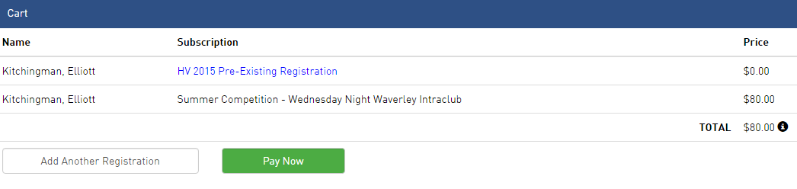

If you have any questions about the registration process, please contact Elliot Kitchingman via email at treasurer@waverleyhc.org.au or via phone on 0432415337 (for urgent queries only).

