BBQ & Canteen
Duty Guide

Juniors Friday Nights & Saturday Mornings

How does the Canteen operate?

Junior teams run a BBQ & the canteen every Friday night during the Junior season to provide parents / players / spectators with access to a variety of “dinner” food. Juniors and their families in doing so will help increase club income from both the food and drinks.

Junior teams run the canteen every Saturday morning during the Junior season to provide parents / players / spectators with access to coffee/tea, drinks & food and generate income for the Club from the canteen.

What are the roles & responsibilities associated with the WHC canteen?

WHC Operations Manager:
- Oversee the smooth operations of the whole of the WHC to ensure the centre is clean and safe.
- Oversee that food served in the canteen is served in accordance with food safety and safe handling of food guidelines.
- Purchase the canteen food and BBQ supplies. Ensure these foods are stored safely and food safety records are kept.
- Ensure all food equipment is clean and safe to be operated.
- Communicate with the Canteen volunteers the roles and expectations of the Canteen volunteer for the shift.
- Set up the cash registers for the start of the shift and cash in at the end of the shift.
- It is not the role of the Operations manager to serve customers – this is the primary role of the canteen volunteers.

Contact Details

Operations Manager
Name: Emma Smart
Phone: 0423 326 497
Email: operationsmanager@waverleyhc.org.au

Roster Co-ordinator:

- Setup the roster of when BBQ and Canteen duty is required based on Friday and Saturday morning HV fixtures.
- Friday night:
  - 2 for canteen, 2 for BBQ, 2 for bar should be rostered,
- Saturday morning:
  - 2 for canteen, 2 for food prep (for lunch / afternoon). Note: if a junior team decides to run the BBQ this would be in addition to these volunteers
- Will only assign a team to each slot, it is the Team Manager`s responsibility to assign individuals. Where juniors decide to do the duty, a parent needs to be there to supervise since food safety needs to be cared for and the duty involves the handling of hot food and drinks as well.
- Timeslots should overlap by 15 mins minimum in order to enable volunteers to handover to next team of volunteers
- Will send roster with assigned teams to games, to all Team Managers so they can ask for individual volunteers.
- Notes down individual names, received from Team Managers, to the games
- Note: teams will only be rostered on when their team is playing at the ground, depending on the number of games fixture one or multiple teams may be assigned the Friday night / Saturday morning. For example if games are running from 6pm to 10pm it is recommended an U14 team is allocated the first two games and an U16 team picks up the final game.

Roster Co-ordinator
Name: Susanne Gottstein
Phone: 0450 011 439
Email: susannegottstein@aol.com

Team Manager:

- Will work with the Roster Co-ordinator to ensure each team does volunteer to support the canteen and BBQ duties as assigned.
- The Roster Co-ordinator will only assign a “team”, it will be the responsibility of the Team manager to work out who is covering and how this is shared across the team.
- Friday night:
  - 2 for canteen, 2 for BBQ, 2 for bar should be rostered,
- Saturday morning:
  - 2 for canteen, 2 for food prep (for lunch / afternoon). Note: if a junior team decides to run the BBQ this would be in addition to these volunteers
- It is also the Team Manager`s responsibility to remind volunteers in the lead up to their volunteering slot (eg.. remind them via email or text).
- Step through the Canteen Volunteer instructions below so they are clear of their role.
- Note
- Panthers: Will be responsible for 8-9.30am each Saturday,
- U10 and U12 teams will be responsible for the time slots for rest of Saturday morning (based on who has a game at the ground)
- U14 and U16 are responsible for Friday nights depending on fixtures

Canteen Volunteer (parent or player):

- Contact the other Canteen Volunteer rostered at the same time as you and confirm they will be attending the shift. Encourage each other to be on time!
- Turn up for your shift as agreed via the roster, sign into the “canteen volunteers” book in the canteen
- Follow the instructions contained in this guide and also posted in the canteen
- If players under the age of 18 are assisting in the canteen a responsible adult must be in attendance supervising the handling of money, hot food and safe food handling practices
- Handover to the next group of volunteers at the end of your shift – and sign out of the volunteers book
- Under the direction of the Operations manager assist them to set up the canteen and WHC centre and clean and close the WHC centre at the end of each playing day.

What is the process if a Canteen volunteer does not arrive for their shift?

From 2016, Junior parents and senior player volunteers will man the WHC canteen. This is now not the role of the Operations Manager.

In the unlikely event that a canteen volunteer does not turn up to do their shift, the most senior committee member at the ground will execute the following options at the time –
- Encourage the last volunteer to remain until the Canteen volunteer arrives
- Call for another volunteer currently at the ground to do the shift and then they can swap their shift with the person who did not arrive.
- If these options are not viable close the canteen.

When is the Canteen operational?

BBQ & Canteen - Fridays
- All Fridays during season
- From first game to last game scheduled as per HV fixture

Canteen – Saturday mornings
- All Saturdays during season
- 8-9.30am Waverley Panthers
- 9.30-12 noon timing based on first junior game to last junior game scheduled as per HV fixture

Junior season Dates
Round 1: 29th April, 2016.
Week breaks: School Holidays – 25th March, - 10th April, 2016
Last Round: 26th August – Semi Finals Start U14 & U 16

What times are Canteen Volunteers required?

Fridays
- 5.45pm setup BBQ / canteen
- 6pm Start Cooking Sausages on B.B.Q. / work in canteen – Serve Drinks, food etc.
- Cook sausages and onions until half time of last game
- Pack up – Clean B.B.Q. down by end of last game / close canteen.

Saturday mornings
- 8am open canteen
- Pack up - Clean B.B.Q. down by end of last game / close canteen

What is the process for running the BBQ ?

- Use either the portable B.B.Q or the permanent outdoor B.B.Q.
- Always wear Food Handling Gloves when handling food.
- Once BBQ is setup / heating up get sausages / hamburger patties, onions and B.B.Q spray oil out from the canteen.
- Depending on what is being served also get out other ingredients such as lettuce, tomato, bread etc.. and take out to the B.B.Q. area stored in appropriate containers.
- Note: only take enough ingredients out of the fridge / canteen area that you will need for the immediate period, this will reduce any risk from food being stored at the wrong temperature or contamination of food being left out
- Cook sausages / hamburgers patties / onions etc on B.B.Q.
- Place already cooked sausages in roasting tray to keep warm (do not cook all sausages up at once, try and estimate how many you will need to the immediate time period and only cook those).
- Customers are to pay for sausages at the canteen where they receive a ticket to give to the B.B.Q. head chef.
- Once finished cooking the B.B.Q. it needs to be cleaned down, lid placed on B.B.Q. and any leftovers brought into the Canteen for later sales.

Barbeque Food Handling Safety Tips

Cleaning and hygiene
- Clean all your equipment and food preparation areas before and after you use them.
- Ensure all food handlers wash their hands before and after handling food items
- Remove waste and clean the barbecue.

Storage
- Keep sausages in an insulated cooler.
- Only remove sausages from the cooler when you’re ready to cook them.
- Never leave meat sitting around at room temperature.
- Protect bread and onions from insects and dust by keeping them wrapped, or in sealed containers.
- Do not re-freeze sausages that have been thawed.
- Throw out any sausages left over at the end of the fundraiser.

Cooking
- Always cook sausages thoroughly.
- Always use clean utensils.
- Never use the same plate or tongs for raw and cooked foods.
- Wear gloves when handling food. However, for safety reasons don’t wear them if you are cooking food.

Canteen food safety and handling tips

There are how to guides in the canteen to explain how to use the cash register and how to cook / handle some of the food items. Follow these guides and if unsure ask for help.

- Those serving at the Canteen need to also wear Food Handling Gloves when touching any food items.
- Your primary role is to serve all customer who come up to the counter – this is not the Operations Manager’s job – they need to be focused food safety and keeping food supplied and stocked.
- There are how to guides in the canteen to explain how to use the cash register and how to cook / handle some of the food items. Follow these guides and if unsure ask for help.
- Restock fridge when needed.
- Put more food items on to cook when needed (do not cook more food than is required in the immediate period, bearing in mind how long it takes to cook some items (refer the food handling/cooking guides in the canteen).
- Check sauce bottles outside & clean table.
- Wash, dry & put away dishes - keep kitchen clean.
- Check all rubbish bins outside – empty if needed.
- Check clubroom & changing room toilets – restock if needed & tidy up.
- ANYTHING else the Operations Manager needs help with.

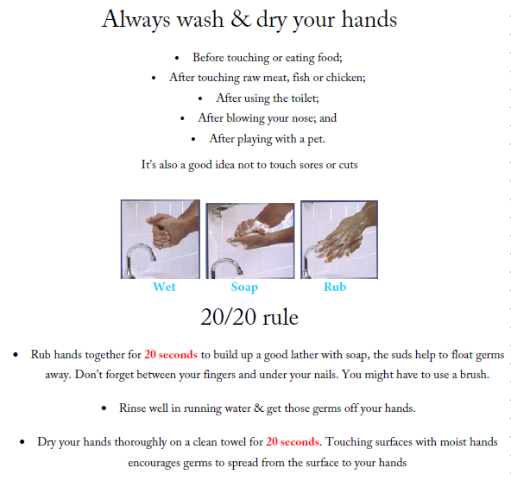

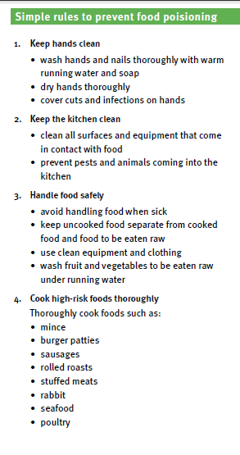 | 